Lab No. 05 & 06

STL Sequential &

Customized Generic Container:

List Tasks
Task 1: Find Maximum [4+4+2=10]
Create an integer type list of size 500 and populate this list. Use this list for following subtasks.
- Write a function which returns the maximum value of the passed list. Its prototype would like as follows;
int list_max(list <int> &ls);
int list_max(list<int> &ls)
{
int max = *ls.begin();
for (int x : ls)
{
if (x > max)
max = x;
}

return max;
}

2. Write a function which adds index position of the passed list in the existing values of this passed list.
void list_seq_num(list <int> & ls);
void list_seq_num(list<int> &ls)
{
int index = 0;

for (auto it = ls.begin(); it != ls.end(); it++)
{
*it = *it + index; // value + index
index++;
}
}
3. Test these functions by making call to them in a main() function.
Code:
#include <iostream>
#include <list>
using namespace std;
int list_max(list<int> &ls){
int max = *ls.begin();
for (int x : ls){
if (x > max)
max = x;
}
return max;
}
void list_seq_num(list<int> &ls) {
int index = 0;
for (auto it = ls.begin(); it != ls.end(); it++){
*it = *it + index;
index++;
}
}
int main(){
list<int> ls;
for (int i = 0; i < 500; i++){
ls.push_back(i + 1);
}
int maxValue = list_max(ls);
cout<<"Maximum value"<<maxValue<<endl;
list_seq_num(ls);
cout <<"Updated list (first 10 values) ";
int count = 0;
for (int x : ls){
cout << x << " ";
count++;
if (count == 10) break;
}
return 0;
}
Output:
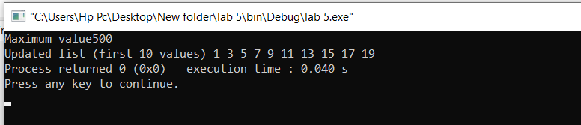

Task 2: Tricky List Printing [10]
You are given two lists, firstList and secondList, containing integers sorted in ascending order. The operation printLots(firstList, secondList) will print the elements in firstList that are in positions specified by secondList. For instance, if secondList = 1, 3, 4, 6, the elements in positions 1, 3, 4, and 6 in firstList are printed.
Write the function printLots(firstList, secondList) to perform the above algorithm. Use only the public STL list container operations.

Code:
#include <iostream>
#include <list>
using namespace std;
void printLots(list<int> &firstList, list<int> &secondList){
auto it = firstList.begin();
int index = 0;
for (int pos : secondList){
while (index < pos && it != firstList.end()){
it++;
index++;
}
if (it != firstList.end()){
cout << *it << " ";
}
}
}
int main(){
list<int> firstList = {10, 20, 30, 40, 50, 60, 70};
list<int> secondList = {1, 3, 4, 6};
printLots(firstList, secondList);
return 0;
}
Output:
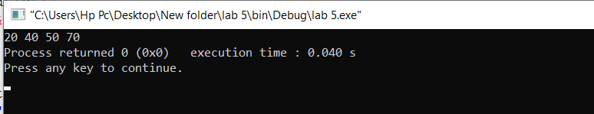

Task 3: List Intersection & Union [10]
Given two sorted lists, L1 and L2, write a function list_union to compute L1 ∪ L2 using only the basic list operations.
Code:
#include <iostream>
#include <list>
using namespace std;
list<int> list_union(list<int> &L1, list<int> &L2){
list<int> result;
auto it1 = L1.begin();
auto it2 = L2.begin();
while (it1 != L1.end() && it2 != L2.end()){
if (*it1 < *it2){
result.push_back(*it1);
it1++;
}
else if (*it2 < *it1){
result.push_back(*it2);
it2++;
}
else{
result.push_back(*it1);
it1++;
it2++;
}
}
while (it1 != L1.end()){
result.push_back(*it1);
it1++;
}
while (it2 != L2.end()){
result.push_back(*it2);
it2++;
}
return result;
}
int main(){
list<int> L1 = {1, 3, 5, 7};
list<int> L2 = {2, 3, 6, 7, 8};
list<int> result = list_union(L1, L2);
for (int x : result){
cout << x << " ";
}
return 0;
}
Output:
